**Screenshots Displaying Results**

1. Shows the list of folders created using etl.py script & a deep dive into the time folder.

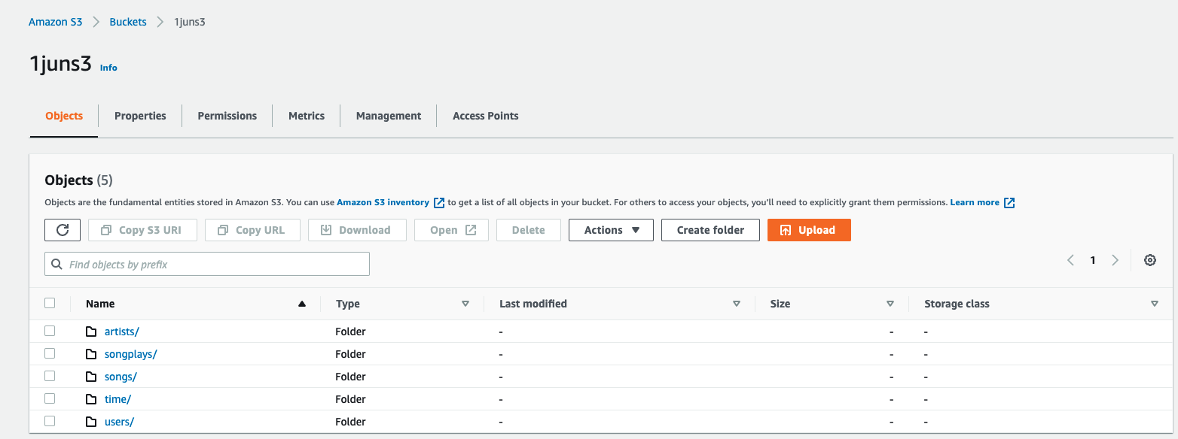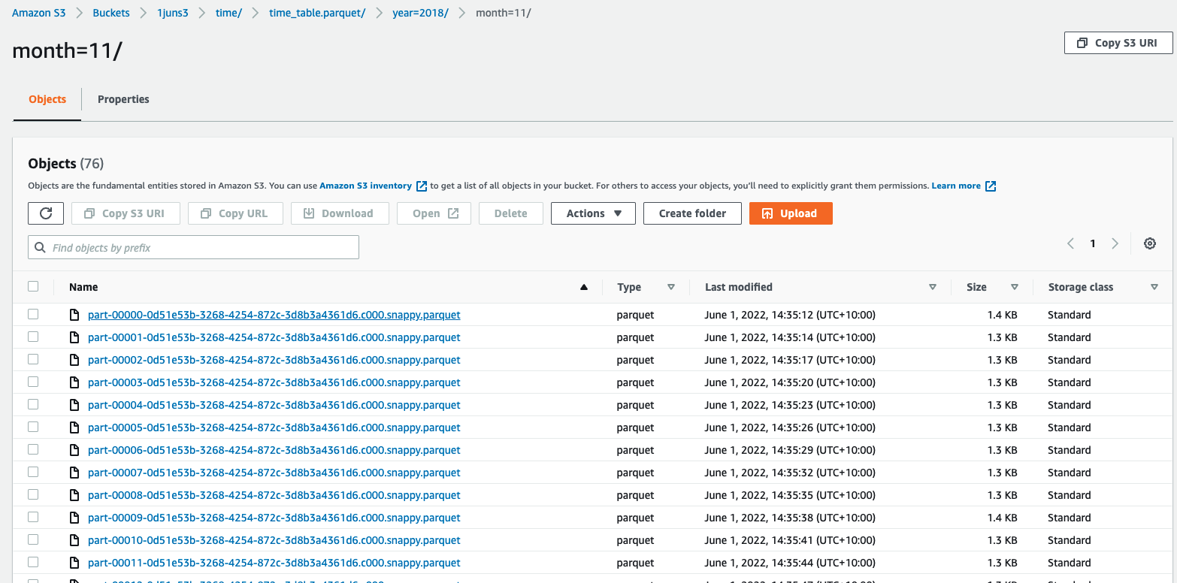

1. Confirming the running of the script without errors along with the time taken.

